**SYNOPSIS**

**ON**

**“WEB CHAT APPLICATION”**

Submitted to the Department ofComputer Application

By

**Anshika Gaur (2301640140035)**

Anuradha kumari (2301640140042)

Ashish Tiwari (2301640140055)

Ankit Singh Chauhan (2301640140031)

Vishal Mishra (2301640140211)

Under the supervision of

**Deepali Nigam**

**(Assistant Professor)**

**Designation – MCA (II year/III Semester)**

**(2024 – 2025)**



**Pranveer Singh Institute of Technology**.

Kanpur - Agra - Delhi National Highway - 19 Bhauti -Kanpur – 209305

(Affiliated to Dr. A.P.J. Abdul Kalam Technical University, Lucknow)



**INDEX**



**TABLE OF CONTENTS**

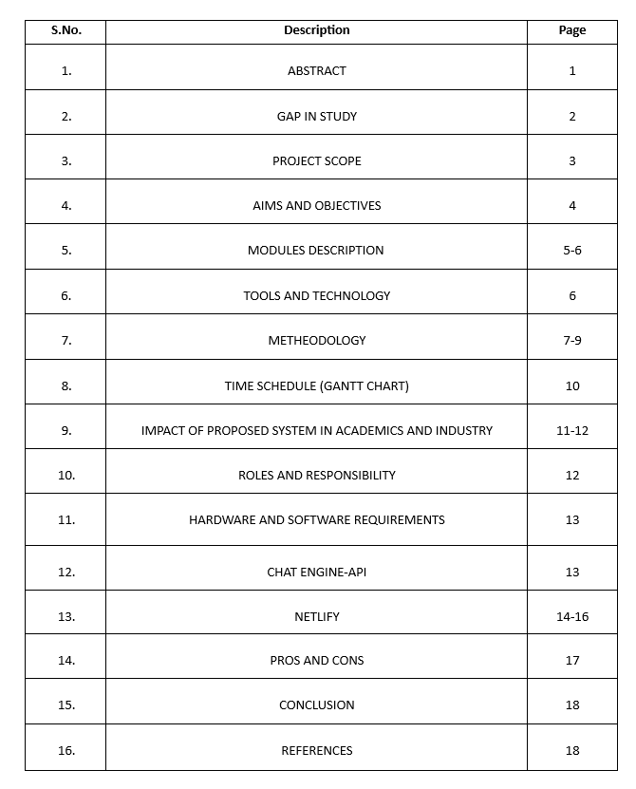

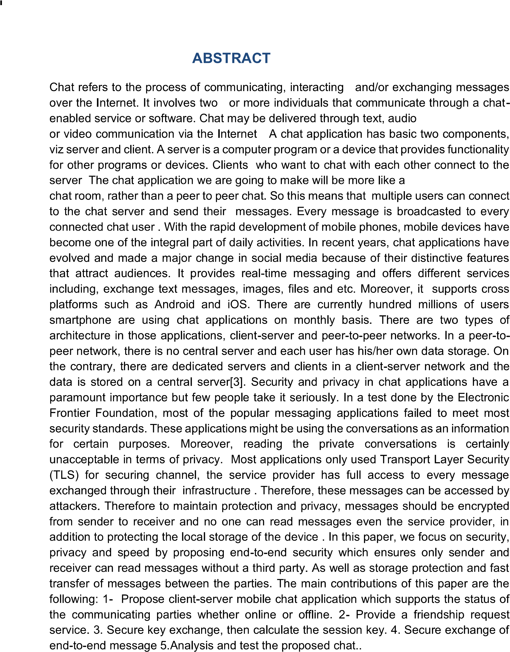

**ABSTRACT**



**GAP IN STUDY**

* **Scalability Issues:** Many current chat applications struggle with handling large numbers of simultaneous users or real-time message loads. Your project can aim to address this with better load balancing or cloud integration.
* **Security Concerns:** Some chat applications may not implement strong encryption (e.g., end-to-end encryption), leaving user data vulnerable to hacking. Your project could focus on enhancing security features like encrypted messaging and secure authentication.
* **User Experience:** Some applications have complicated interfaces or slow message delivery times, affecting usability. Your project could aim to improve the user interface (UI) and reduce latency in message delivery.
* **Offline Functionality:** Many web chat apps fail to offer reliable offline support or message synchronization when users reconnect. Your project could address this by implementing offline message queuing and synchronization.
* **Advanced Features:** Popular chat applications might not support advanced functionalities such as file sharing, multimedia messages, or group chats effectively. Your project can focus on integrating these features more efficiently.

**PROJECT SCOPE**

**1. Project Overview:**

* Develop a real-time web chat application that allows users to exchange messages in real-time using web technologies.

**2. Key Features:**

* **User Authentication:** Implement user registration, login, and authentication (email/password or OAuth).
* **One-on-One Chat:** Enable private messaging between two users.
* **Group Chat:** Create and manage group chats where multiple users can communicate.
* **Real-Time Messaging:** Implement real-time communication using WebSockets or similar technologies (e.g., Firebase, SignalR).
* **Message Persistence:** Store messages in a database (e.g., MySQL, MongoDB) for retrieval even after users disconnect.
* **User Presence:** Show online/offline status of users.
* **Typing Indicators:** Indicate when another user is typing in the chat.
* **Media Sharing:** Allow users to share images, files, or videos in chat.
* **Notifications:** Implement notifications for new messages, especially when the user is offline.

**3. Technology Stack:**

* **Frontend:** HTML, CSS, JavaScript, React or Vue.js for UI.
* **Backend:** Node.js with Express or Django/Flask for the server-side.
* **Database:** MongoDB, Firebase, or MySQL for message storage.
* **Real-Time Communication:** WebSockets (Socket.IO or native WebSockets) or Firebase Realtime Database.
* **Authentication:** JWT tokens or OAuth (Google/Facebook login).

**4. Milestones/Deliverables:**

* Setup of the project structure and environment.
* User authentication system implementation.

**AIMS AND OBJECTIVES**

**Aims:**

1. **Develop a Functional Real-Time Chat System:**
   * The primary aim is to build a functional web-based chat application that enables real-time communication between users over the internet.
2. **Demonstrate Practical Application of Web Technologies:**
   * The project aims to apply various web technologies, including front-end and back-end development, real-time data transfer, and user interface design, to create a fully operational system.
3. **Enhance Understanding of Real-Time Communication Systems:**
   * Gain hands-on experience in developing real-time communication features, such as WebSockets, which are critical for modern web applications like chat systems, video calls, and gaming platforms.
4. **Implement Secure Communication:**
   * Develop a secure system where users can register, log in, and communicate with confidence, focusing on authentication, data privacy, and security.

**Objectives:**

* **Enable Real-Time Communication:** Allow users to send and receive messages instantly through a web interface.
* **Provide Secure User Authentication:** Ensure that only authorized users can access the platform with proper login and authentication mechanisms.
* **Support Private and Group Chats:** Facilitate both one-on-one messaging and group conversations.
* **Store and Retrieve Message History:** Allow users to access previous chats by saving messages in a database.
* **Ensure User Engagement:** Include features like typing indicators, online status, notifications, and media sharing to enhance the chat experience.

**MODULES DESCRIPTION**

1.**User Authentication Module:**

* **Key Features:**
  + User registration (sign up)
  + User login (sign in)
  + Password encryption

2. **Messaging Module:**

* **Key Features:**
  + One-on-one private messaging
  + Group messaging
  + Real-time updates using WebSockets
  + Typing indicators and read receipts

3. **User Presence Module:**

* **Key Features:**
  + Display online/offline status
  + Update in real-time as users' presence changes

4. **Chat History and Persistence Module:**

* **Key Features:**
  + Store and retrieve messages from the database (e.g., MongoDB, MySQL)
  + Message history for both private and group chats
  + Message deletion and archiving options

5. **Media Sharing Module:**

* **Key Features:**
  + Upload and send media files
  + Store files in a secure location (database or cloud storage)

**6.Notification Module:**

* **Key Features:**
  + Real-time message notifications
  + Sound or pop-up alerts

7. **Group Management Module:**

* **Key Features:**
  + Create and join group chats
  + Manage group members (add/remove users)
  + Assign group roles (e.g., admins)

8. **Security and Privacy Module:**

* **Key Features:**
  + Data encryption (e.g., SSL/TLS)
  + User authentication and session management
  + Role-based access control

**TOOLS AND TECHNOLOGY**

1. **Authentication:**

* **JWT (JSON Web Tokens):** For secure user authentication and session management.
* **OAuth (Google, Facebook):** To enable third-party login options.

2. **Real-Time Communication:**

* **WebSockets/Socket.IO:** For real-time, bi-directional communication between server and clients.

3. **Version Control:**

* **Git/GitHub:** For source code management and collaboration.

4. **Deployment:**

* **Heroku, AWS, or Firebase Hosting:** To deploy the application and make it accessible online.

**METHODOLOGY**

* **Frontend Technologies:**
* **HTML/CSS:** For structuring and styling the user interface.
* **JavaScript (React, Vue, or Angular):** To build interactive, dynamic, and responsive UI elements.
* **Bootstrap/Tailwind CSS:** For faster, responsive design development.
* **Backend Technologies:**
* **Node.js with Express (or Django/Flask):** To handle server-side logic, API requests, and real-time data flow.
* **Socket.IO or WebSockets:** For real-time messaging and live updates between client and server.
* **Database:**
* **MongoDB/MySQL/PostgreSQL:** For storing user information, chat messages, and media files.
* **Firebase Realtime Database:** An alternative for real-time database management.

**ERD OF WEB CHAT APPLICATION**

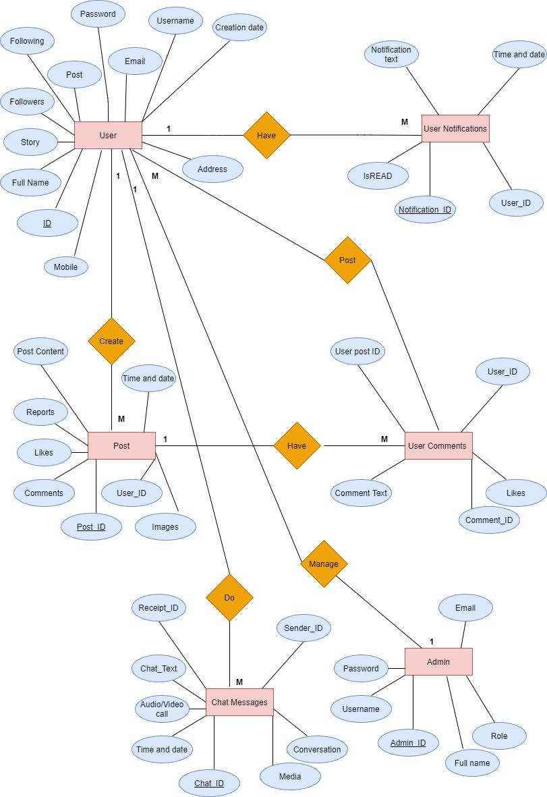

**DFD OF WEB CHAT APPLICATION**

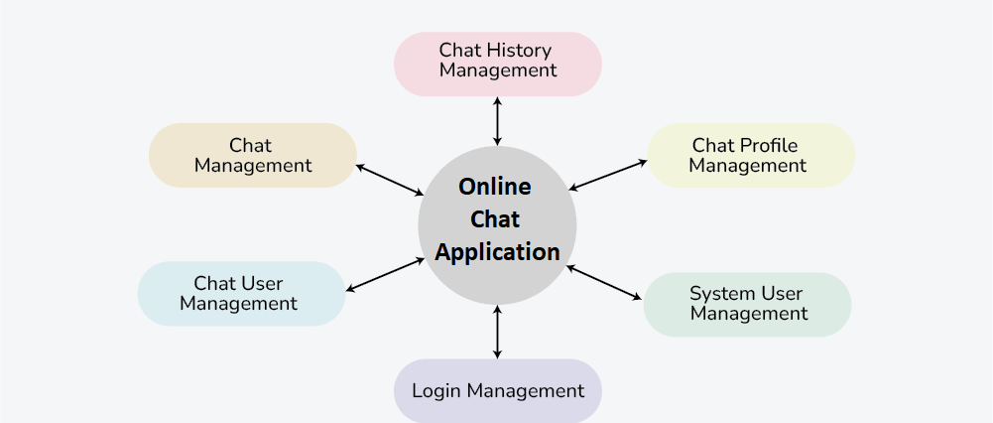

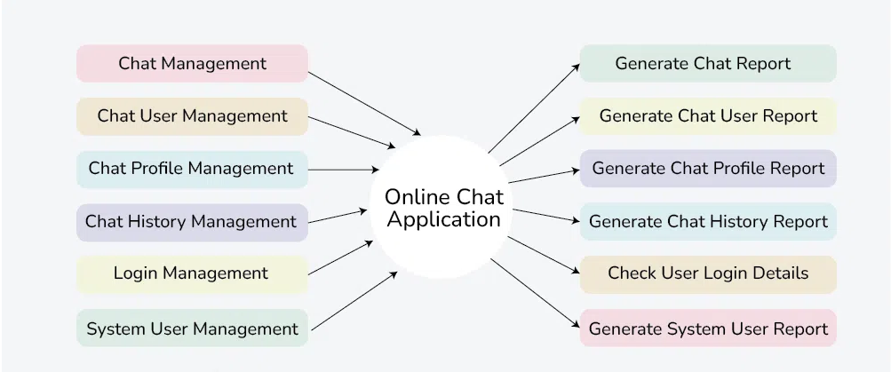

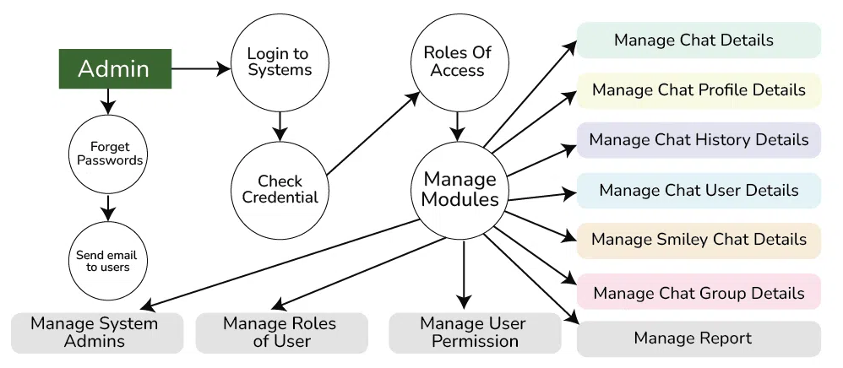

**TIME SCHEDULE (Gantt Chart)**

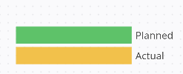

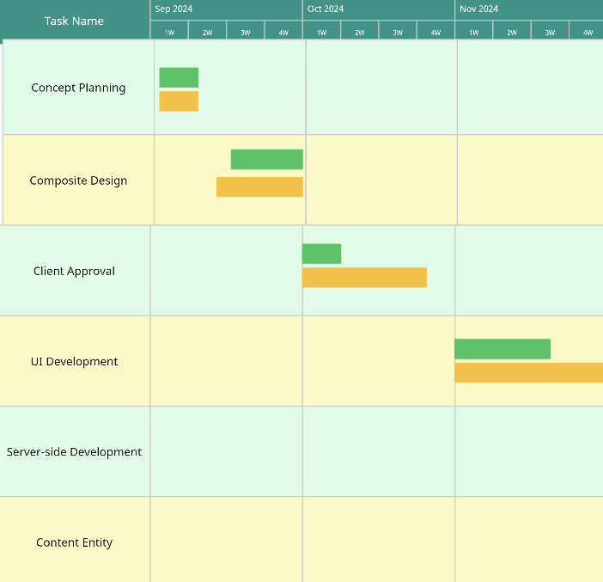

**IMPACT OF PROPOSED SYSTEM IN ACADEMICS AND**

**INDUSTRY**

**1. Academics:**

* **Improved Communication and Collaboration:** Web chat applications enable real-time communication between students, teachers, and staff, allowing for more immediate feedback and interaction during projects or coursework. This fosters collaboration and group work, even in remote settings.
* **Access to Instant Help:** Students can use chat apps to connect with peers or instructors, seeking instant clarification on doubts. This helps in promoting active learning, especially in online or hybrid learning environments.
* **Centralized Resources:** Web chat applications often integrate with file-sharing and learning management systems, making it easier for students to access and share study materials, assignments, and resources.
* **Enhanced Peer Interaction:** It facilitates student communities and study groups to work together on projects, assignments, and revisions, leading to better outcomes through collaborative learning.
* **Integration with Academic Tools:** Modern web chat apps integrate with academic platforms (like Google Classroom, Microsoft Teams) making academic management, communication, and resource sharing smoother.

**2.** **Industry:**

* **Efficient Team Communication:** For businesses, chat applications enable real-time, quick communication among team members across departments or geographical locations. This increases productivity by eliminating the delays associated with email.
* **Collaboration on Projects:** It allows for immediate sharing of information, updates, and feedback in real time, promoting faster decision-making and coordination among cross-functional teams.
* **Customer Support and Engagement:** In industries like e-commerce, chat applications help businesses provide instant customer support, increasing satisfaction and engagement.
* **Integration with Business Tools:** Web chat applications are often integrated with task management, customer relationship management (CRM), and other business platforms, which streamlines workflows, reducing the need for switching between multiple platforms.
* **Remote Work Support:** With the rise of remote and hybrid work, web chat applications are critical in maintaining team cohesion and ensuring seamless communication between distributed teams.

**ROLES AND RESPONSBILITY**

**1. Admin/Moderator:**

* Manage user accounts and permissions.
* Monitor chat activity and enforce rules.
* Ensure data security and privacy compliance.

**2. User (Student/Employee):**

* Communicate with peers and instructors/colleagues.
* Share files, resources, and updates.
* Participate in group chats or discussions.

**3. Developer/Support Team:**

* Maintain application performance and updates.
* Troubleshoot issues and provide technical support.
* Implement new features and integrations.

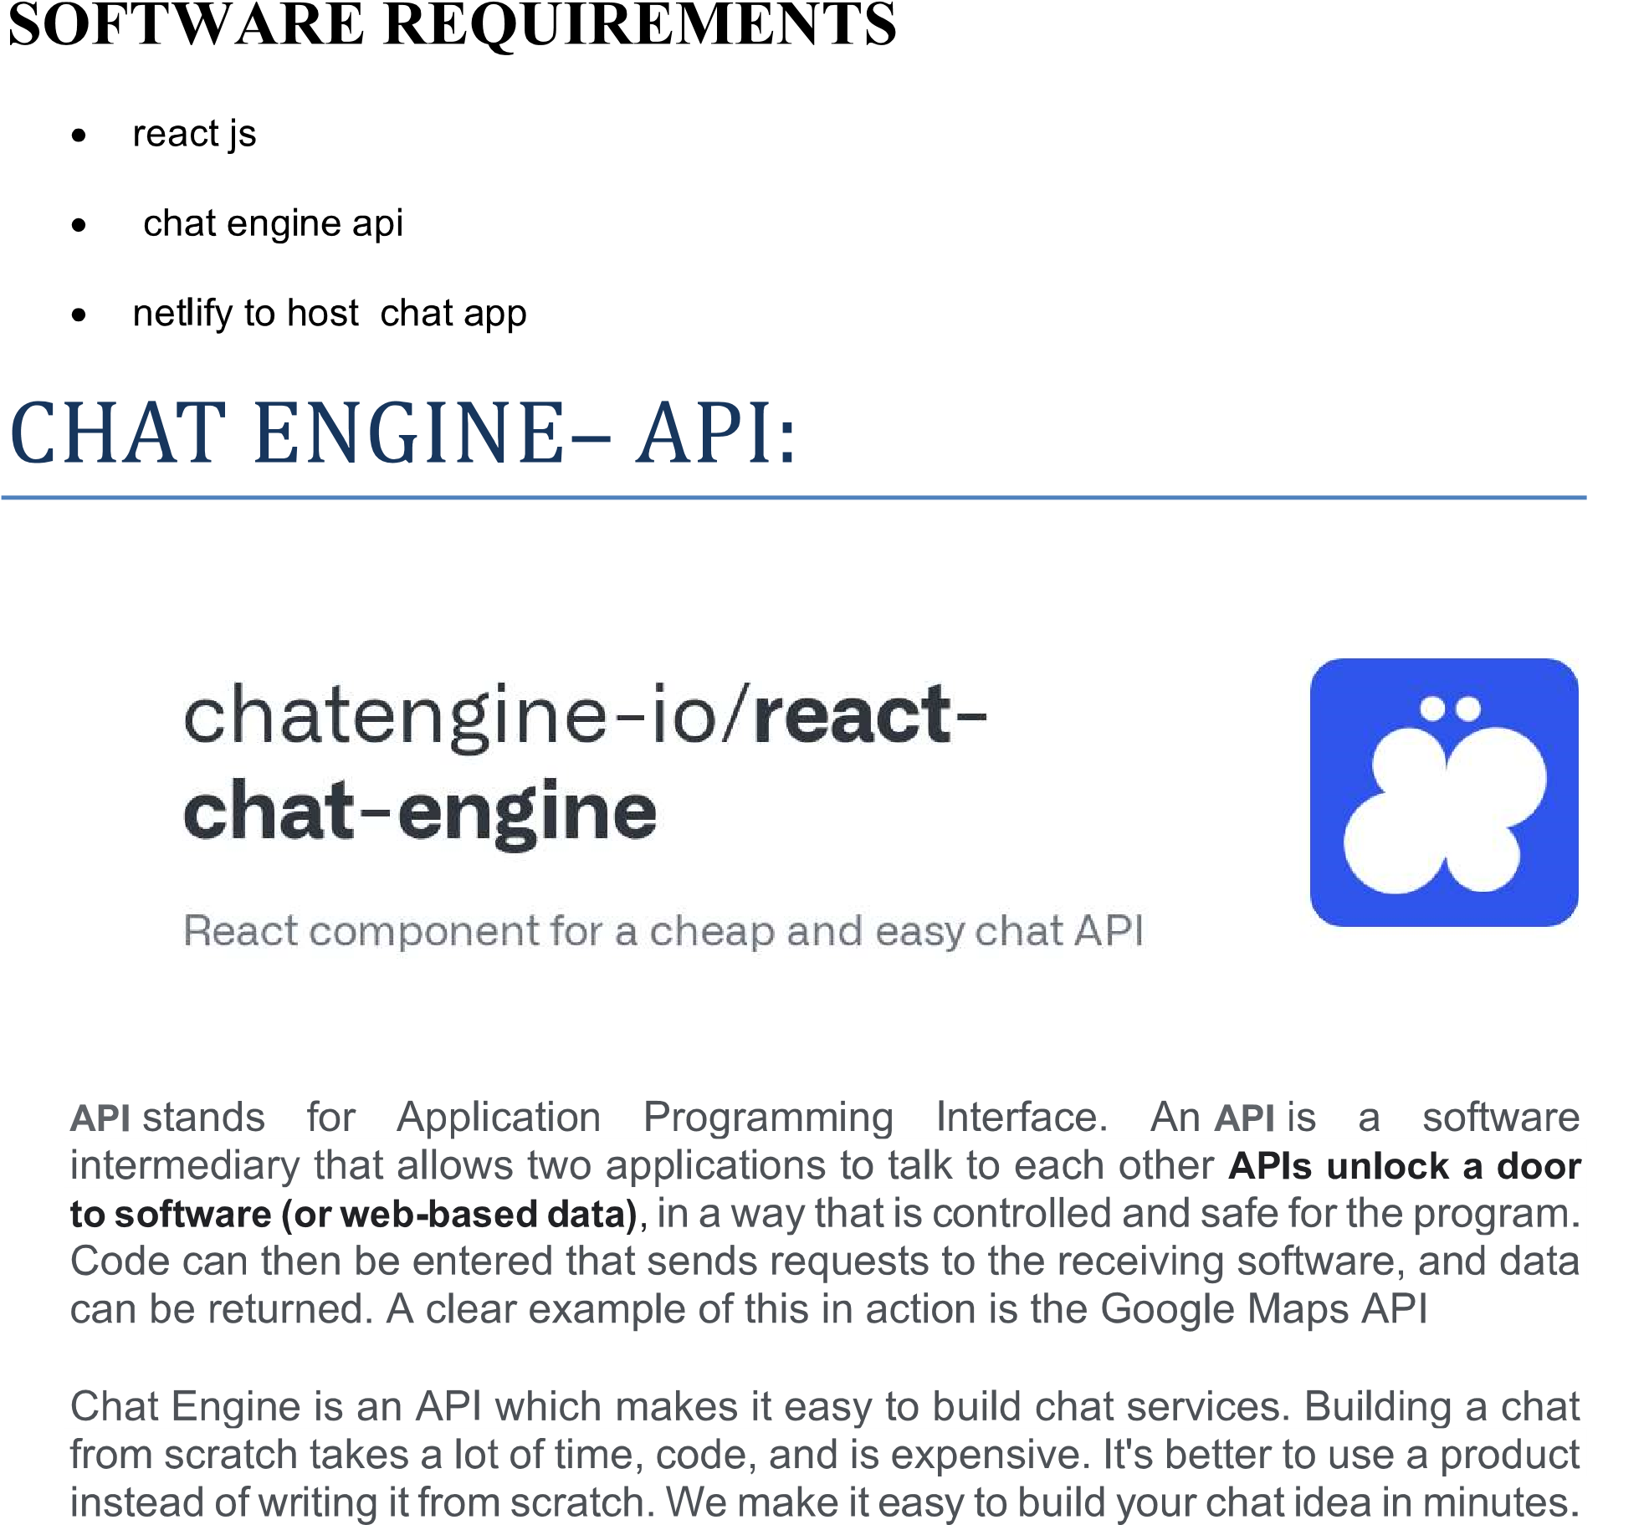

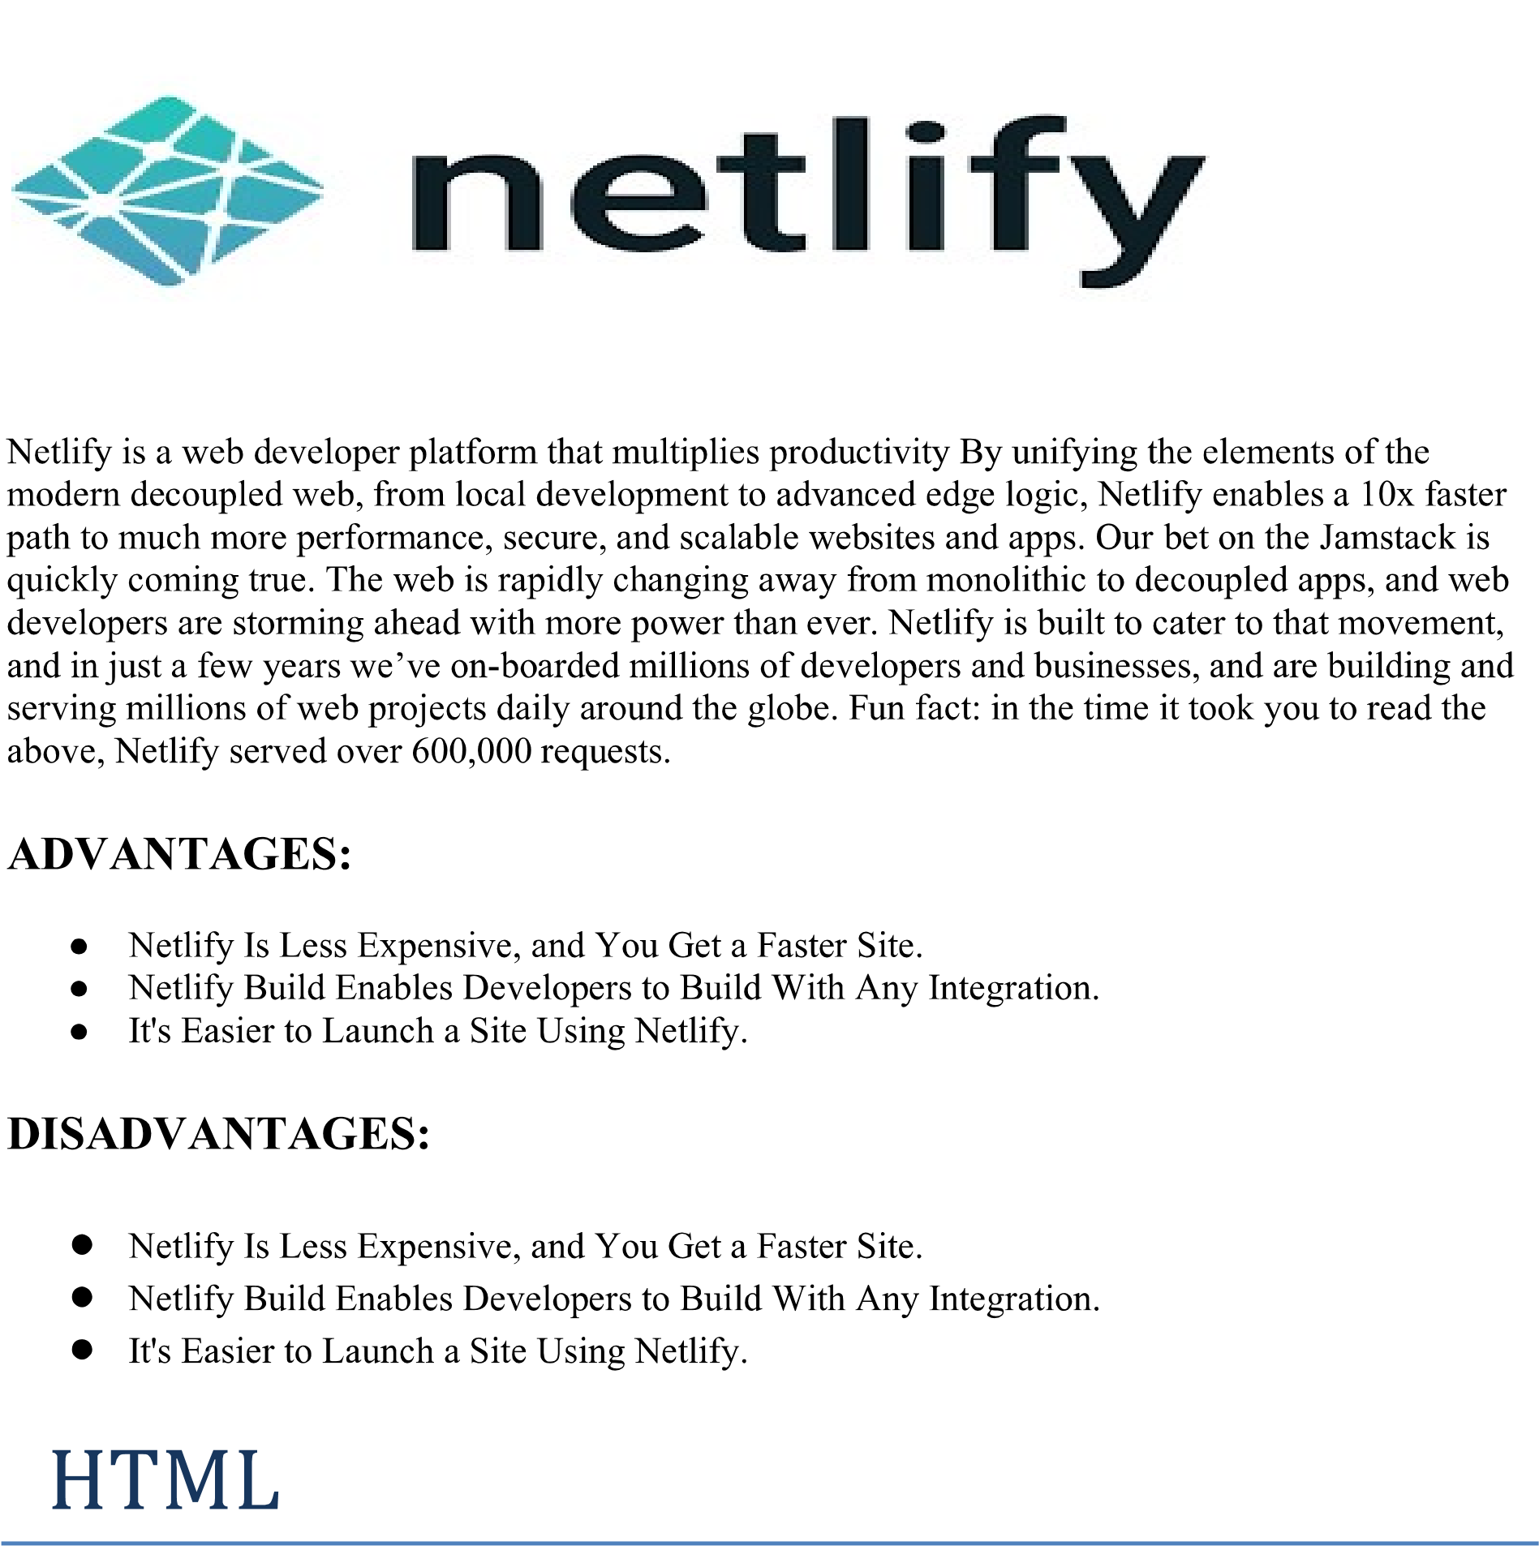

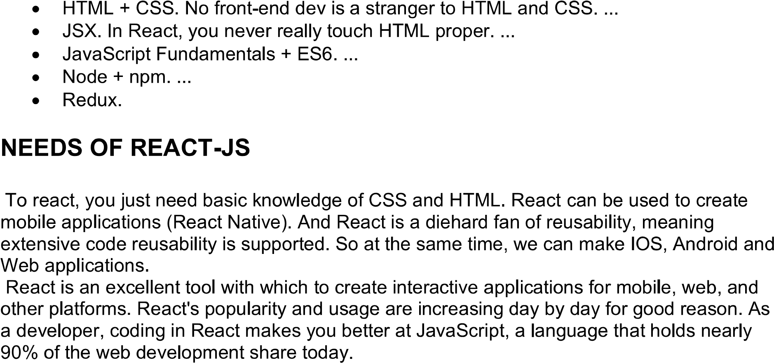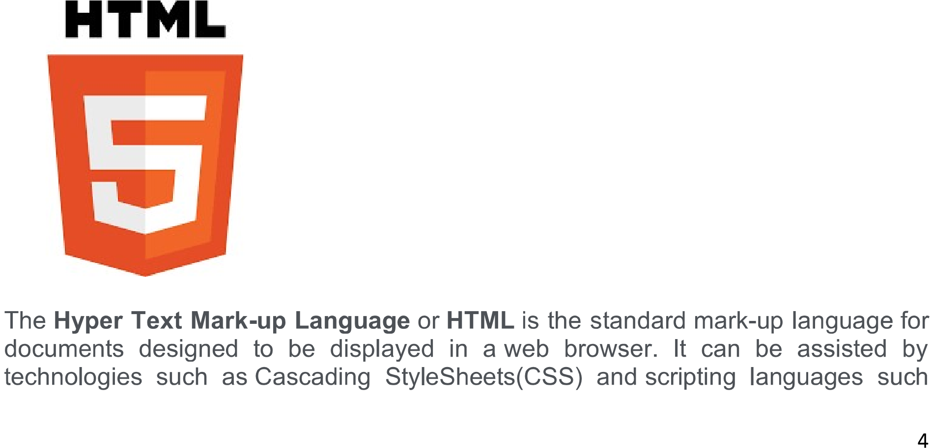

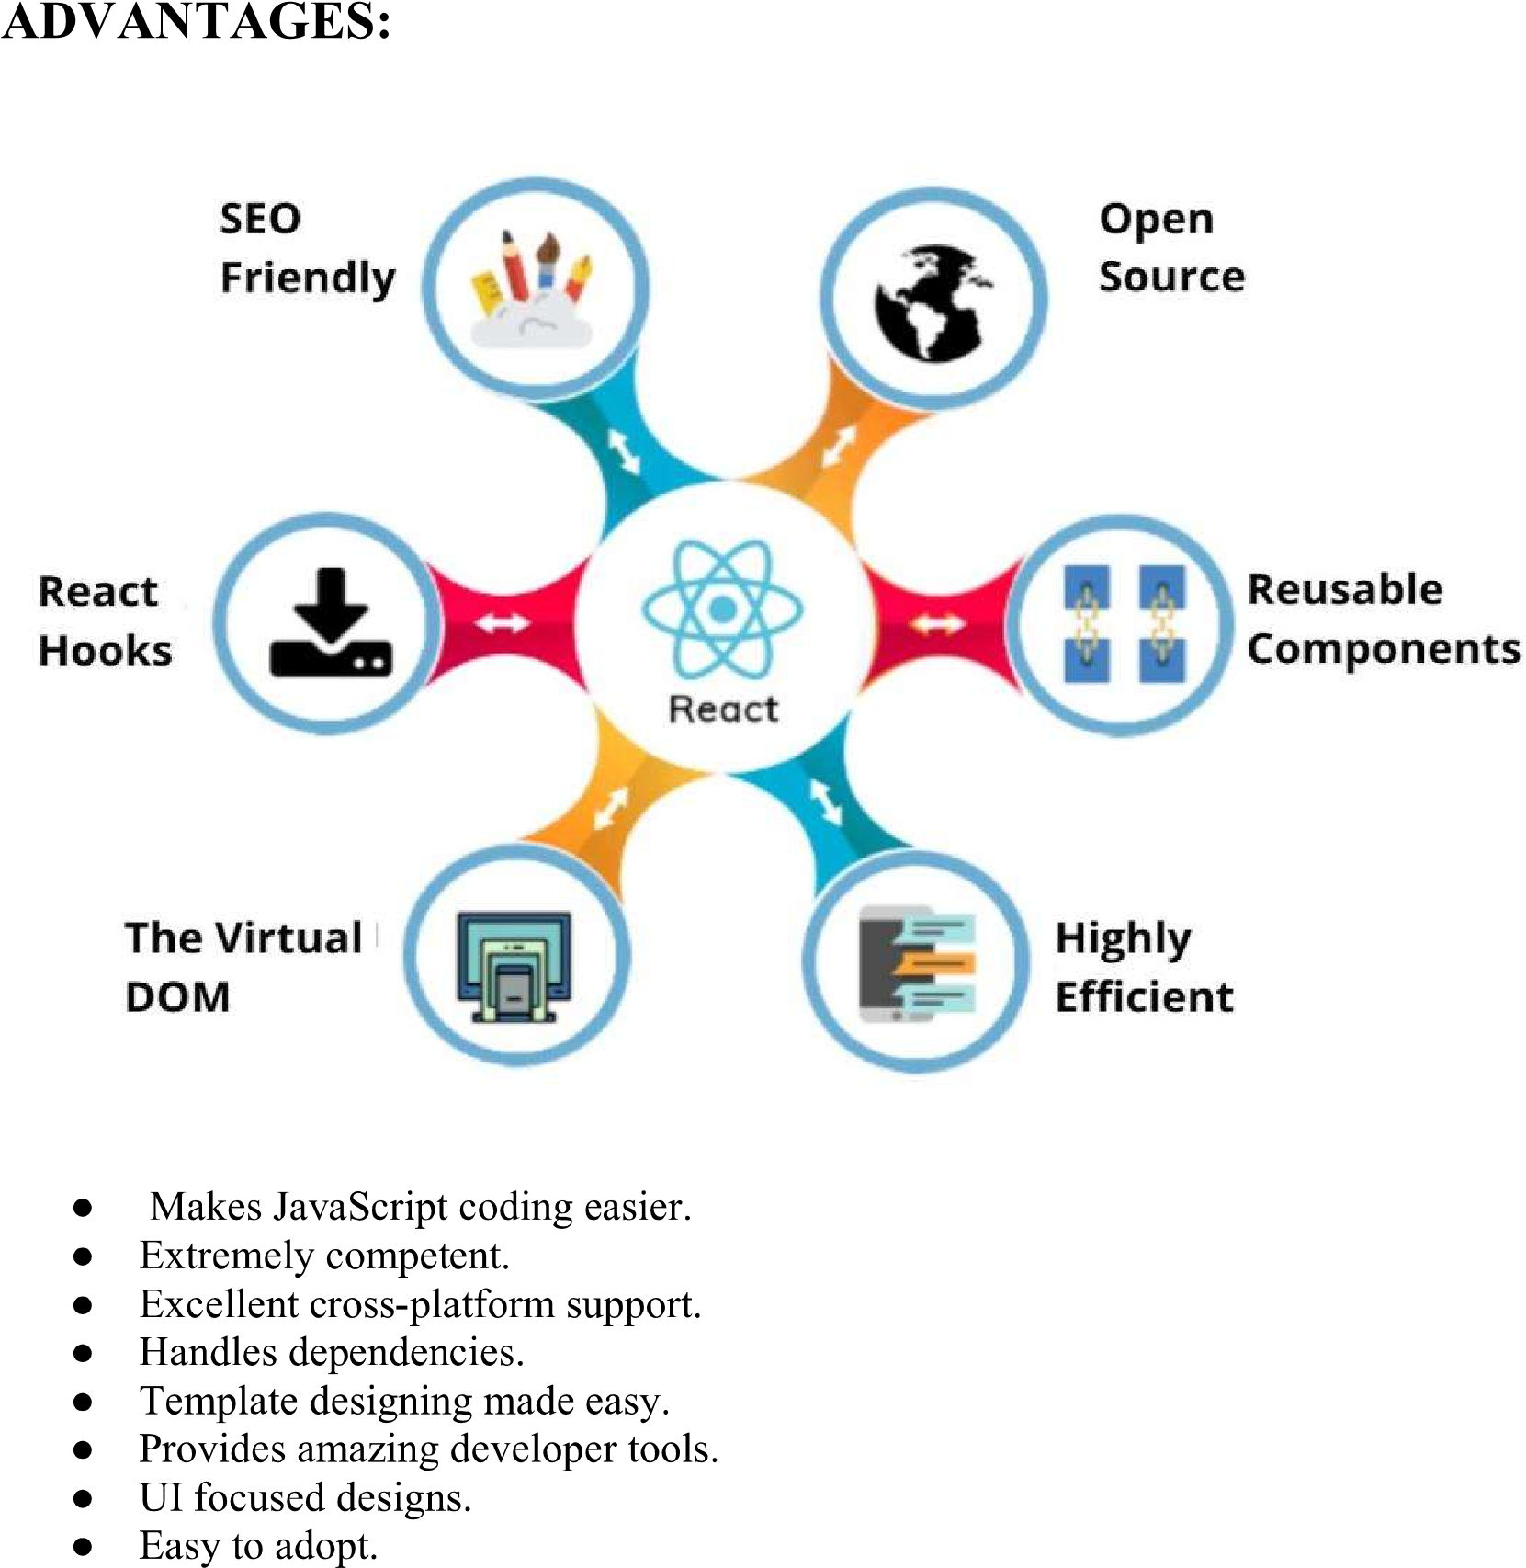

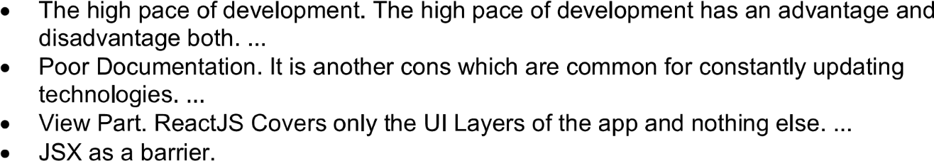 **DISADVANTAGES:**

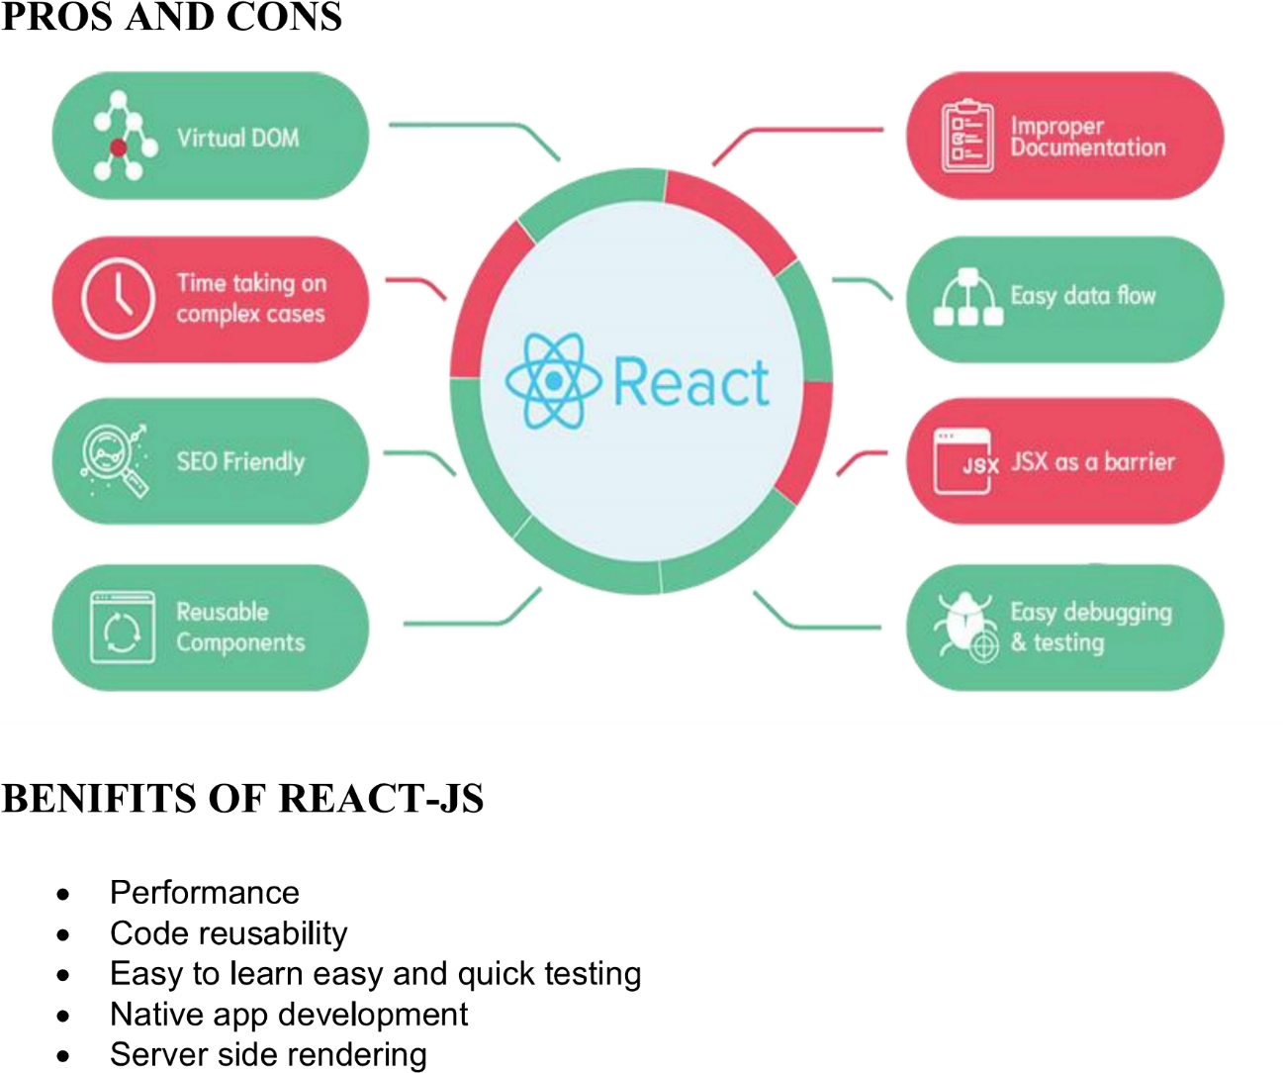

**CONCLUSION**

The proposed web chat application aims to create an efficient and user-friendly platform for real-time communication. This project will not only enhance academic collaboration among students and educators but also improve communication within industries. By incorporating features like user authentication, private and group chats, message notifications, and media sharing, the application provides a comprehensive tool for effective interaction.

The application will utilize modern web technologies, ensuring a responsive and engaging user experience. Additionally, it emphasizes security and privacy, making it safe for users to communicate and share information. The roles of admins, users, and developers are clearly defined, ensuring smooth operation and management of the platform.

Overall, this project represents a practical application of web development skills and provides valuable experience in creating a real-time communication system, which is increasingly relevant in both educational and professional settings. The impact of such a system extends to better engagement, collaboration, and efficiency, ultimately enriching the user experience in various contexts.

**REFERENCES**

**WEB SOURCE: -**

1. https://geeksforgeeks.org

2. <https://javatpoint.com>

3. https://www.wikipedia.org

4. https://www.techopedia.com